1
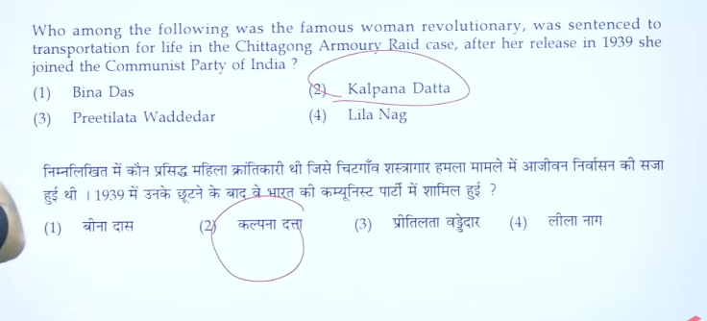

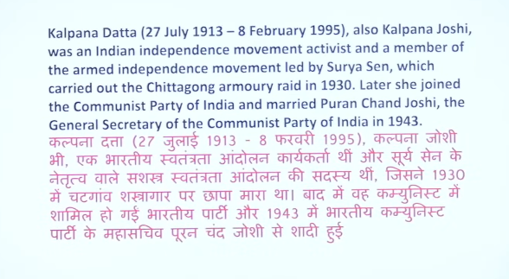

2
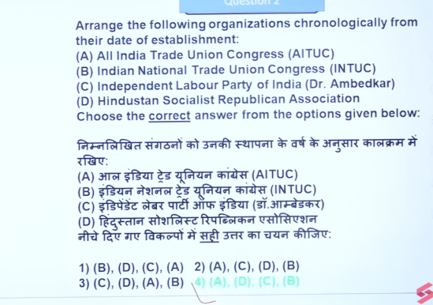
👉 All India Trade Union Congress 1920 Lala Lajpat Rai as its first president.
👉 Indian National Trade Union Congress 1947 Gulzarilal Nanda
👉 The Independent Labour Party 1936 B. R. Ambedkar.
👉 Hindustan Socialist Republican Association 1928 Bhagat Singh, Chandrashekhar Azad, and others.

The All India Trade Union Congress (AITUC) 1920 was established in Bombay (now Mumbai), India, on October 31, 1920. It is the oldest trade union federation in India and was founded by Lala Lajpat Rai to represent the interests of the working class.]
👉 All India Trade Union Congress = 1920, with Lala Lajpat Rai as its first president.
👉 Indian National Trade Union Congress (INTUC) =1947 was established by Gulzarilal Nanda in 1947. INTUC is associated with the Indian National Congress
👉 The Independent Labour Party (ILP) was founded in 1936 by B. R. Ambedkar.
👉 Hindustan Socialist Republican Association HSRA was formed in 1928 by revolutionaries like Bhagat Singh, Chandrashekhar Azad, and others.

1. Hindustan Socialist Republican Association HSRA was formed in 1928 by revolutionaries like Bhagat Singh, Chandrashekhar Azad, and others.

📌 Background:
- It was a reorganization of the earlier Hindustan Republican Association (HRA)
- Added the word “Socialist” to show focus on equality and workers’ rights

🎯 Objectives:
- To overthrow British rule in India through revolution
- To establish a socialist republic

⚔️ Famous Activities:
- Lahore Conspiracy Case (1929)
- Bombing in Central Legislative Assembly (by Bhagat Singh & Batukeshwar Dutt)

✔️ One-line:
👉 HSRA (1928) was a revolutionary organization formed by Bhagat Singh and others to establish a socialist India by overthrowing British rule.

The Hindustan Socialist Republican Association (HSRA) was founded in September 1928 at Feroz Shah Kotla, New Delhi, primarily by Chandrashekhar Azad, Bhagat Singh, Sukhdev Thapar, and their comrades. It was a reorganization of the Hindustan Republican Association (HRA) to adopt socialist goals.

2. The Independent Labour Party (ILP) was founded in 1936 by B. R. Ambedkar.

The Independent Labour Party (ILP) of India was established by Dr. B.R. Ambedkar in August 1936 to contest the 1937 provincial elections, specifically targeting the rights of workers, laborers, and the depressed classes. It aimed to combat Brahmanical and capitalist structures, securing 15 out of 17 seats in the Bombay Presidency.
📌 Key Points:
- Formed to represent workers (labourers) and depressed classes (Dalits)
- Focused on social justice, labour rights, and equality
- Active mainly in Bombay Presidency
- Later, Ambedkar replaced it with the Scheduled Castes Federation (1942)

👉 ILP was established in 1936 by B. R. Ambedkar for labour and depressed class rights.

3
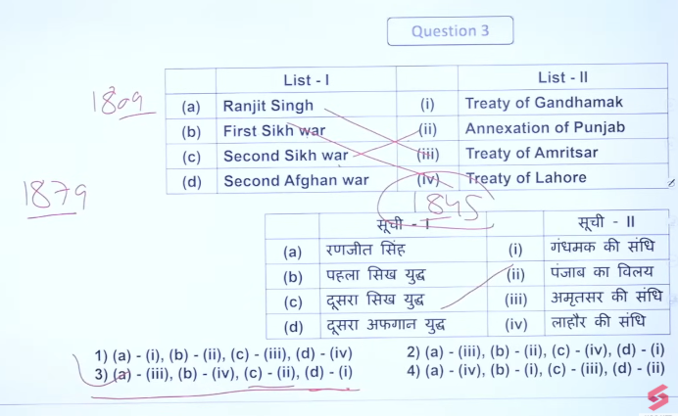

4
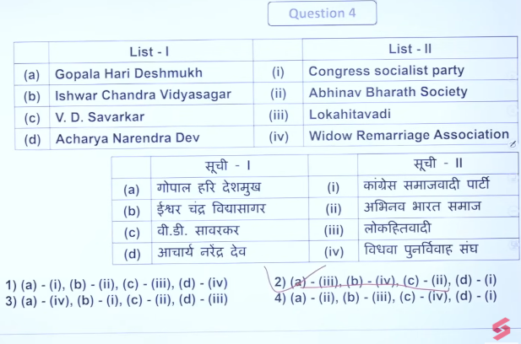

5
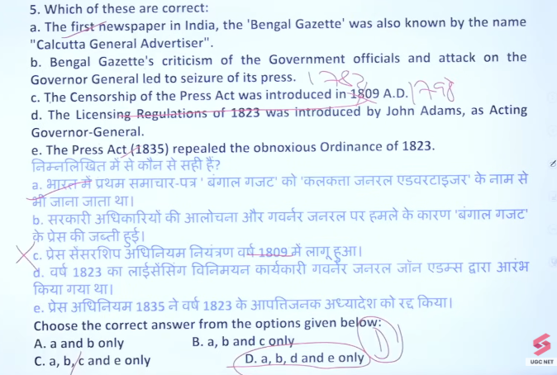

6
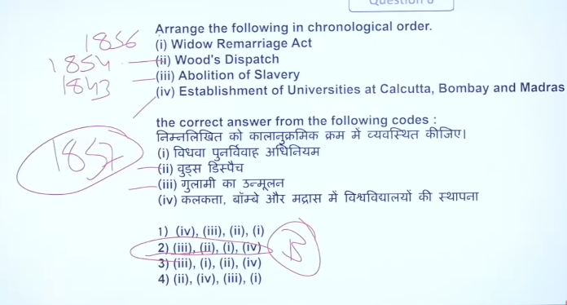

The Hindu Widows' Remarriage Act, 1856 (Act XV, 1856), was passed by Lord Canning on July 26, 1856, in the British East India Company-ruled territories. The bill was drafted by Lord Dalhousie and heavily advocated by the Bengali reformer Ishwar Chandra Vidyasagar, who fought for the rights of Hindu widows.
- Passed By: Lord Canning (Governor-General).
- Drafted By: Lord Dalhousie.
- Key Reformer: Ishwar Chandra Vidyasagar.
- Key Details: It legalised the remarriage of Hindu widows and safeguarded their legal rights and inheritance
.The act was created to improve the social conditions of Hindu widows, particularly child widows, and was a major reform after the abolition of Sati. The first legal Hindu widow remarriage took place on December 7, 1856, under the supervision of Vidyasagar.

Wood's Despatch of 1854, known as the "Magna Carta of English Education in India," was a comprehensive plan drafted by Sir Charles Wood to overhaul the British Indian education system. It established a structured hierarchy, promoted vernacular languages for primary school and English for higher education, and recommended the creation of universities in Calcutta, Bombay, and Madras.
Key Features and Impact:
- Establishment of Education Departments: It led to the creation of the Department of Public Instruction in five provinces.
- University System: It recommended setting up universities in Presidency towns (Calcutta, Bombay, Madras)
.
- Grants-in-Aid: It initiated a system of grants-in-aid to encourage private participation in education.
- Medium of Instruction: It mandated English for higher education while encouraging vernacular languages for primary education.
- Teacher Training: It emphasized the creation of schools for training teachers.
- Vocational Focus: The dispatch encouraged vocational training and female education.
www.kumadvathibed.in +4
Often cited in Indian history, this 100-paragraph report shifted the British policy toward fostering Western knowledge among Indians, setting the stage for modern educational infrastructure, though it was criticized for prioritizing English and promoting a highly centralized, examination-oriented system

7
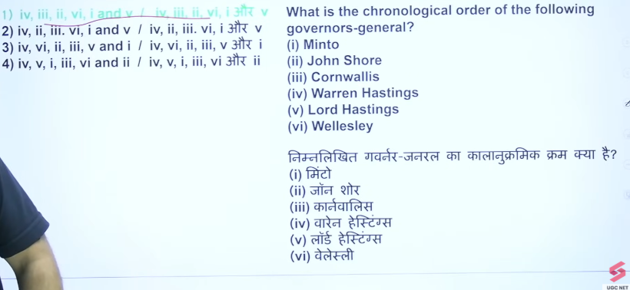

• Warren Hastings 👉 1773 – 1785
• Lord Cornwallis 👉 1786 – 1793
• John Shore 👉 1793 – 1798
• Lord Wellesley 👉 1798 – 1805
• Lord Minto I 👉 1807 – 1813
• Lord Hastings (Francis Rawdon-Hastings) 👉 1813 – 1823

8

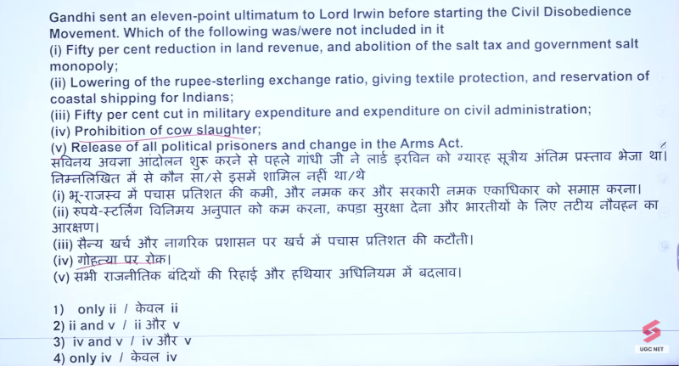
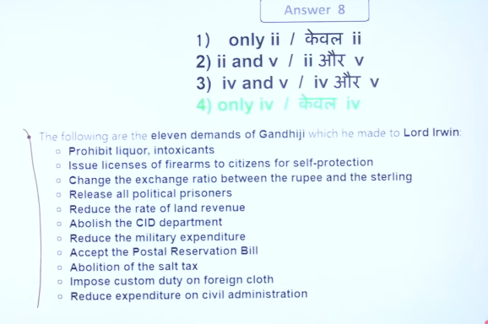

9
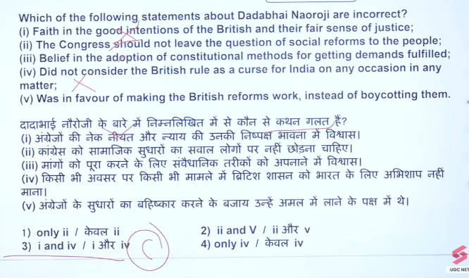

10
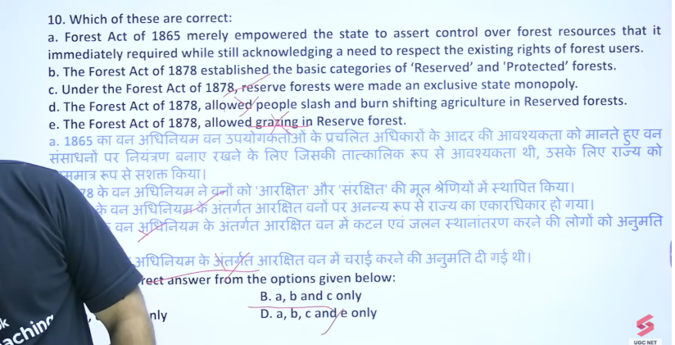

74

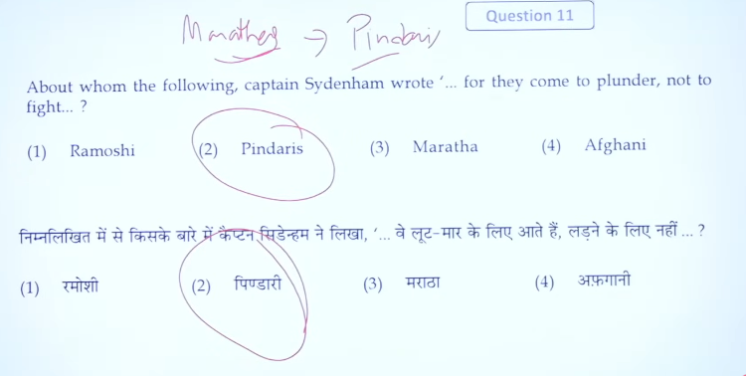

77
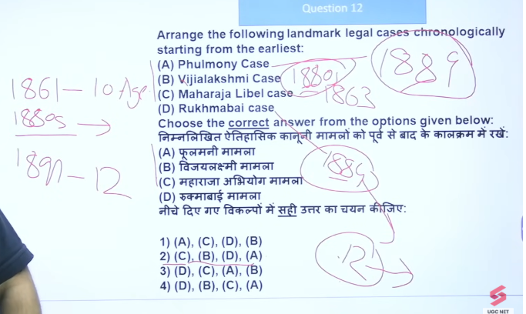

78
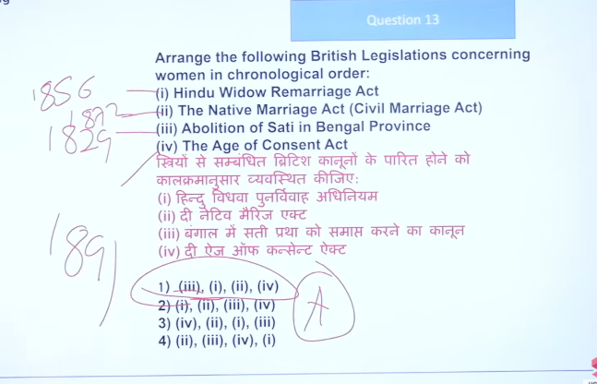

77
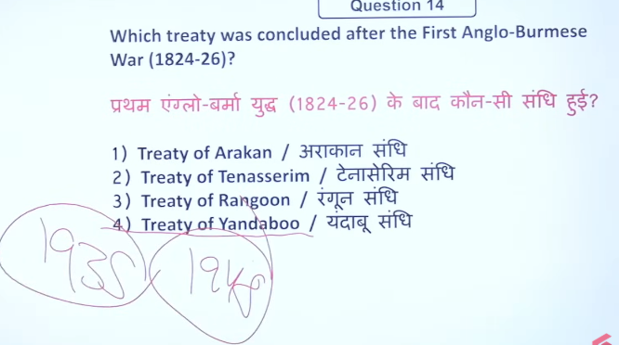

778
34
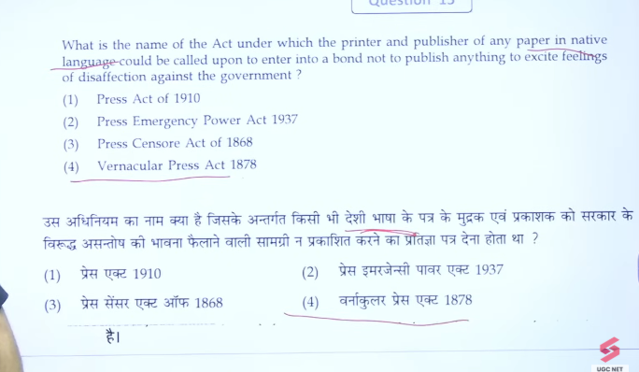

445
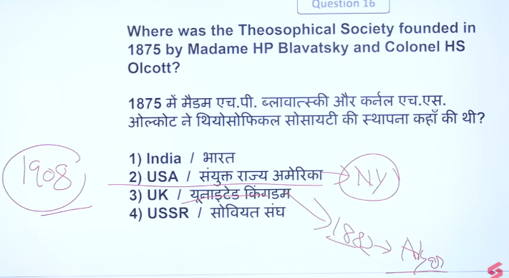

88
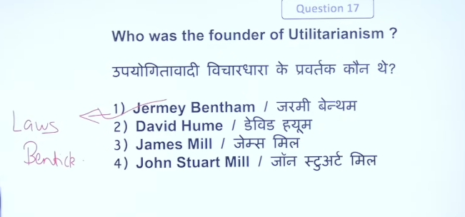

77
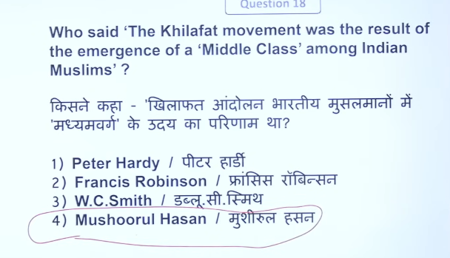

77
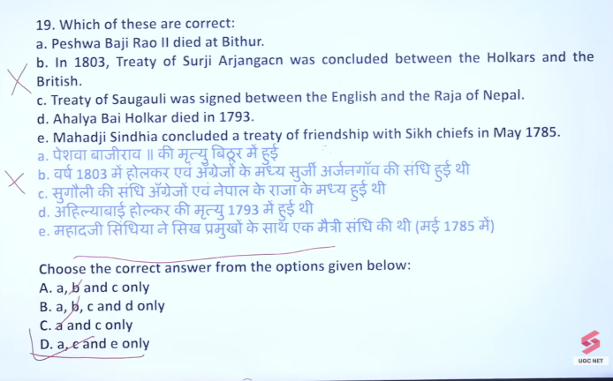

77
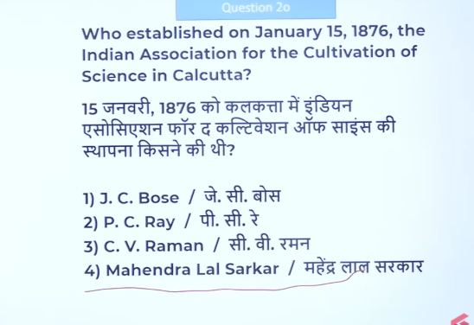

77
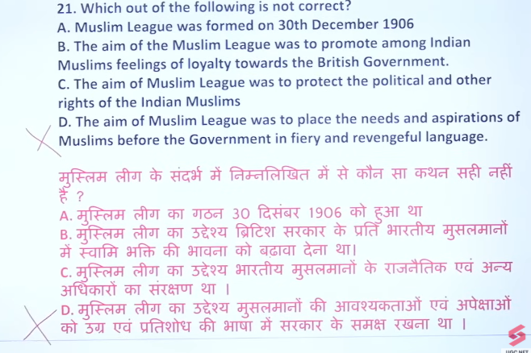

77
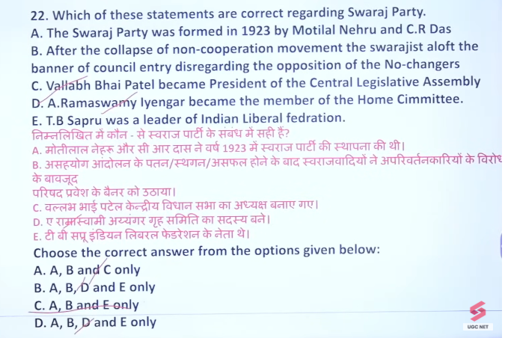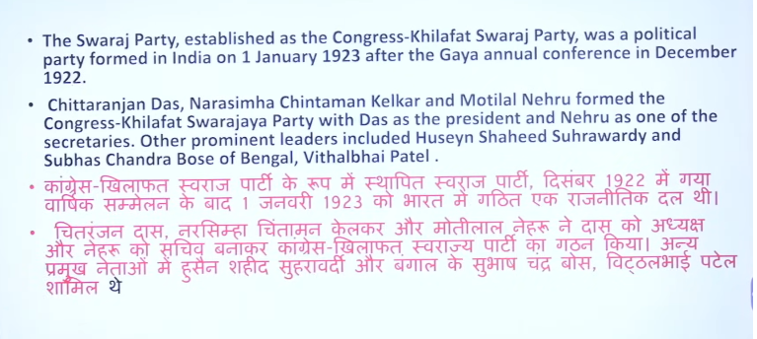

77
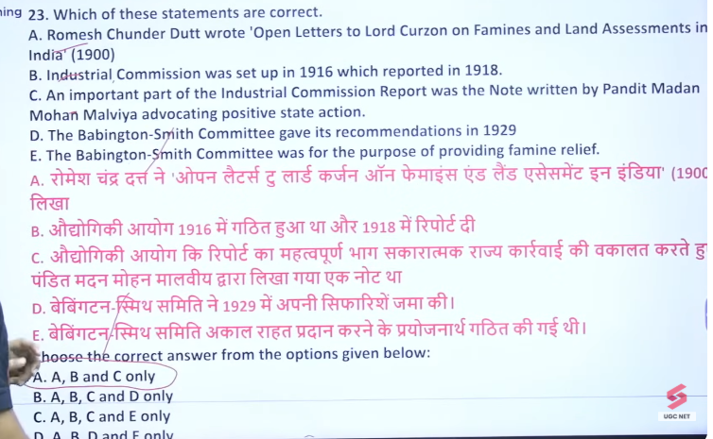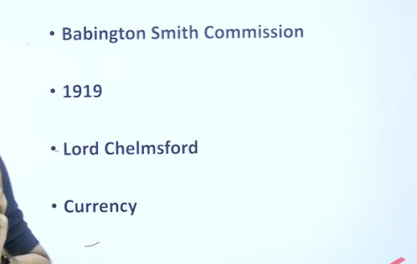

77
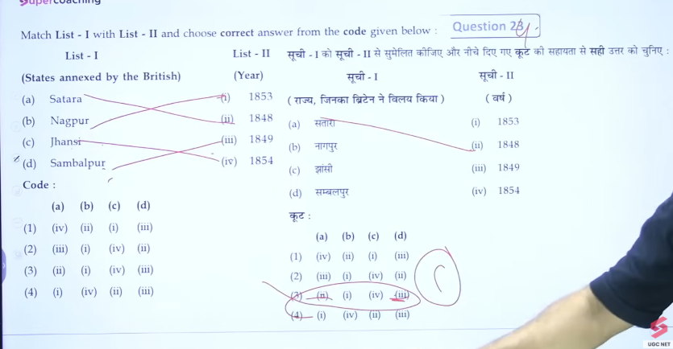

77
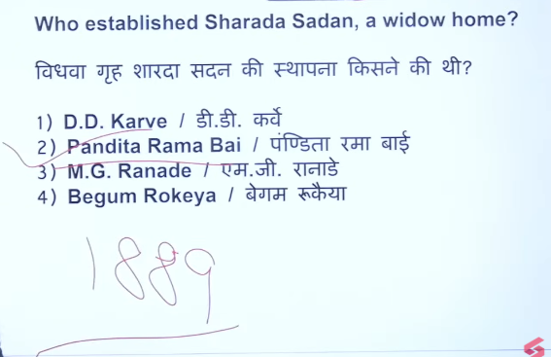

7
